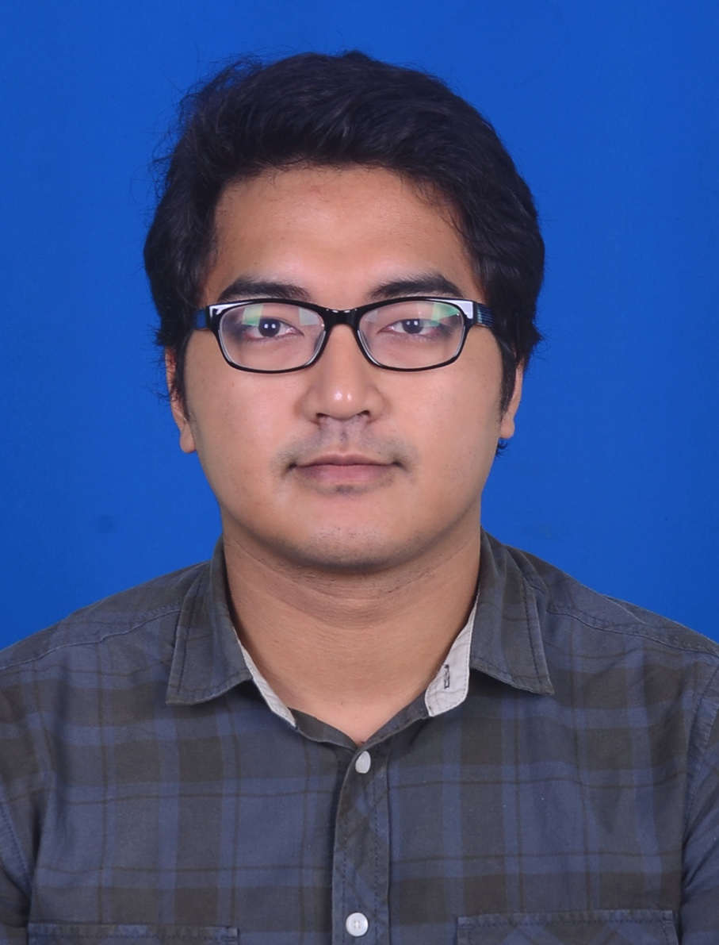

**YUSRISYAM YASIN**

**T:** 011-12953957 **E:** yusrisyam_92@yahoo.com

**● STRENGTH**

* PUNCTUALL
* HARDWORKING
* CAN WORK IN GROUP
* CAN DO MULTIPLE TASK
* RESPONSIBLE
* **INDUSTRIAL TRAINING –** To work in a company with good working environment in order to contribute to society and be a part of it. Also willing to face new challenges in fulfilling the company vision and enhance my potential growth.

**REFERENCES NAME**

MRS. AYUNIZA AHMAD

(INDUSTRIAL TRAINNING COORDINATOR)

**T:** 03-89212278

**E:** Ayuniza@uniten.edu.my

**● REFERENCES**

**● LANGUAGES**

**● EDUCATIONAL BACKGOUND**

**UNIVERSITI TENAGA NASIONAL**

**2014 – PRESENT:** CURRENT CGPA 2.60

* BACHELOR OF ELECTRICAL AND ELECTRONIC ENGINEERING (hons.)

**SEKOLAH MENENGAH SAINS TENGKU MUHAMMAD FARIS PETRA**

**2008 – 2009:** SPM 6A, 3B, 1C

* PURE SCIENCE

**SEKOLAH MENENGAH SAINS TENGKU MUHAMMAD FARIS PETRA**

**2005 – 2007:** PMR 8A



**● ACHIVEMENTS**

* ONGOING – CURRENT CGPA 2.60

**● WORK EXPERIENCE**

**JUN 2010-JULAI 2010**

**FREELANCER: METRO DRIVING ACADEMY,PUCHONG**

* TEACHING STUDENTS ON HOW TO DRIVE A CAR

**● SKILL**

* MICROSOFT WORD
* MICROSOFT EXCELL
* MICROSOFT POWER POINT
* LT SPICE

**● PROFILE**

**FULL NAME:** YUSRISYAM MOHD YASIN

**IC NO :** 921020-03-5873

**AGE:** 25

**DATE OF BIRTH:** 20 OCTOBER 1992

**PLACE OF BIRTH:** HOSPITAL BESAR KOTA BHARU KELANTAN

**HEALTH:** EXCELLENT

**HEIGHT:** 178CM

**WEIGHT:** 89KG

**NATIONALITY:** MALAYSIA

**LANGUAGE:** ENGLISH, MALAY

**PERMANENT ADDRESS:** 3397, TAMAN HUSRAH, PANCHOR, PENGKALAN CHEPA, 16100, KOTA BHARU, KELANTAN.

**MALAY**

**ENGLISH**